# ATOS 5 - XL 光学扫描测量系统方案

**型 号 : ATOS 5 - XL**

|  |  |  |  |  |
| --- | --- | --- | --- | --- |
| 条目 | 产品 | 单位 | 单价 (人民币) | 总价 (人民币) |
| ATOS 5 - XL 光学测量系统 | | | | |
| 1 | ATOS 5 – 扫描头  含 MV 170 | 1 套 |  |  |
| 支撑架 | 1 套 |
| 移动式工作站 | 1 套 |
| ATOS Professional 软件 | 1 套 |
| ATOS Touch Probe | 1 根 |
| 2 | Tritop 系统 | 1 套 |  |  |
| 3（选配） | 测量镜头 MV500 | 1 套 | - |  |
| 4（选配） | 测量镜头 MV1000 |  |  |  |
| 总价: | | | |  |

|  |  |
| --- | --- |
| 报价形式: | 到货客户工厂 |
| 有效期: | 30 天 |
| 货期: | 收到 30%定金后4个月. |  |
| 付款: | 预付款 30%，发货前 70%， |  |
| 备注: | 上述报价包括培训、1 年质保 |

**产品预览**

|  |
| --- |
|  |
| **ATOS 5** |

**Tritop 定位系统**

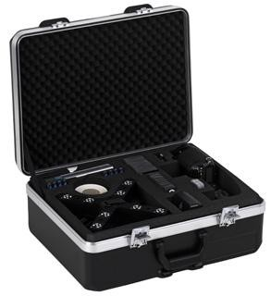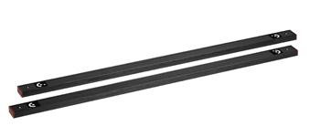

**Technical Description** **技术描述**

**Item 1: ATOS 3D-Scanner, consisting of:**

**ATOS 3D-扫描系统,系统包括:**

**ATOS 5 – sensor head**

**ATOS 5 – 扫描头**

|  |  |
| --- | --- |
|  |  |

* Measuring area: 170x 130 x130 mm
* 单幅测量范围: 170x 130 x 130 mm
* 球形误差（sigma） 0.004mm
* 球间距精度：0.008mm
* 2 x 8 MegaPixel GigE CCD cameras, resolution 3296 x 2472 pixel
* 2 x 8 M 像素的 CCD 相机,分辨率为 3296 x 2472 像素
* Impact resistant housing made from carbon fibre
* 使用碳素纤维材料的机身
* Dimensions: approx. 550 mm x 320 mm x 200 mm
* 尺寸: 大约 550 mm x 320 mm x 200 mm
* Weight: approx. 14 kg
* 重量:大约 14 kg
* LED-Lighting
* LED 投影光源
* Laser pointers for stand-off setup
* 激光指示点用于距离控制
* Integrated controller device
* 集成控制器
* 10 m cable
* 10m 电缆
* Calibration object for this measuring area with calibration certificate
* 与测量镜头对应的校准板
* Transport case
* 包装箱

Image Processing Computer 7820 – Rack Design

机架式图形处理电脑7820

|  |  |
| --- | --- |
|  |  |

* 64 Bit Intel Xeon 2 x 3.0 GHz 12-Core CPU
* 英特尔64位2 x 3.0 GHz12核CPU
* 128 GB RAM
* 128 GB RAM
* NVIDIA Quadro OpenGL graphics card
* 英伟达 Quadro OpenGL 图形显卡
* 24" TFT display with transport case
* 24寸TFT显示器并带有运输箱
* 1 TB SSD hard disk
* 1 TB 固态硬盘
* External USB system backup hard disk for incremental backups
* 外置USB系统备份盘
* I/O: LAN, USB 2.0/3.0
* 数据传输：LAN, USB 2.0 / 3.0
* Wheel mouse, keyboard
* 滚轮鼠标，键盘
* Operating system: Windows 10 (64 Bit)
* 操作系统：Window 10 (64 Bit)
* Transport case on wheels with work plate, adjustable to sitting or standing working position
* 带轮航空箱，包括工作台，可调节立式或卧式的工作站
* 5 years of Dell ProSupport
* 5年戴尔专业支持
* Local Dell ProSupport with 24/7/365 availability by phone or via remote-access
* 戴尔全天24小时电话或远程的专业支持
* On-site service on the next working day after the conclusion of remote diagnosis
* 远程诊断后次日在线服务
* Free spare parts
* 免费配件

# ATOS Professional Software

ATOS 专业版软件

* Measuring process and project administration
* 测量过程和测量项目管理
* Software supported calibration and sensor adjustment
* 支持系统标定和扫描头调整
* Graphic interface for live control of image capture and evaluation
* 实时控制图像捕捉和计算
* Online display of sensor position
* 在线显示测量头位置
* Automatic monitoring of calibration, transformation, movement and projection for each measurement
* 自动检测扫描头精度，拼合精度，扫描过程中的环境振动，光线变化，并自动报警功能
* Complete calculation of 3D coordinates
* 计算三维点云数据

•

* Detection of features: hole pattern, trimming, adapter
* 自动提取特征：孔，槽孔，边界线，胶带线
* Automatic transformation of single measurement views into a common coordinate system based upon reference targets or surface best-fit
* 根据参考点或者 Best fit，自动将多次测量数据自动对齐在统一坐标系下
* Project oriented administration of measurements
* 测量项目管理
* Computation of triangular 3D meshes
* 计算三角网格面数据

•

* Editing of polygon meshes
* 多边形网格编辑
* Import of point clouds and polygon meshes (STL, ASCII, POL, etc.)
* 输入点云数据和多边形网格(STL, ASCII, POL, etc.)
* Polygonization of random point clouds into polygon meshes
* 对无序的点云进行多边形化成多边形网格
* Filling of holes in the polygon mesh by interpolated freeform surfaces
* 根据曲率特征进行补洞
* Smoothing, thinning and refining of polygon meshes
* 对多边形网格进行光顺,细化和提炼.
* Regularization and relaxation of polygon meshes
* 多多边形网格进行规则化和优化
* Repairing, combining and stitching of mesh areas
* 对网格数据进行修复,综合和缝合处理
* Inverting, offsetting and scaling of polygon meshes
* 对多边形网格数据进行转换,偏移和比例缩放.
* Tracing and evaluation of curvatures and character lines
* 跟踪和评估曲率和特征线
* Export of 3D data (ASCII, POL or STL)
* 输出 3D 数据(ASCII, POL or STL)

•

* Construction and measurement planning
* 构造测量计划
* Import of measurement plans
* 输入测量计划
* Creation of primitives on CAD data and polygon meshes
* 在 CAD 数据和多边形网格上构造几何特征
* Construction of equidistant multiple points on areas or along edges
* 在沿着边上或区域上构造等距离的点
* Fitting elements (maximum inscribed and maximum circumscribed elements, Gaussian and Chebyshev methods)
* 拟合元素(最大内圈和最小外圈,高斯等方式)
* Collective sections (axis parallel, radial, along curves)
* 截面线(平行轴,射线等)
* Distances, angel, virtual caliper
* 距离,角度和虚拟卡尺
* Intersection, projection, perpendicular dropping, averaging
* 交点,投影点,垂直点和平均点

•

* Nominal/actual-comparison
* 理论/实际数据对比
* Import of CAD data in standard formats: IGES, VDA, STEP, JT Open, STL
* 输入 CAD 数据(IGES, VDA, STEP, JT Open, STL)
* Import of CAD data in special formats: CATIA v4 / v5, UG, Pro/E, Parasolid
* 输入 CAD 数据:(CATIA v4 / v5, UG, Pro/E, Parasolid)
* Automatic prealignment against CAD without 3D interaction
* 自动根据 CAD 数据进行预对齐
* Definition of coordinate system: 3-2-1, Best Fit, RPS, Plane-Line-Point, etc.
* 定义坐标系: 3-2-1, Best Fit, RPS, Plane-Line-Point, etc.
* Tolerance definition on the CAD data
* 在 CAD 数据上定义公差
* Comparison of actual to nominal CAD data
* 将理论 CAD 数据与实际数据进行比较
* Color plot deviation with pre-defined and customized legends
* 根据预定义和客户化的指定输出彩色偏差图
* Colored inspection sections with needle plots
* 彩色的截面偏差附带针状图
* Full-field computation of material thickness
* 计算材料厚度
* I-Inspect: simple assignment of measuring principles and inspection instructions
* I-Inspect: 单个的测量原则分配
* Evaluation of GD&T according to DIN ISO 1101 and ASME Y14.5
* GD&T 评估根据 DIN ISO 1101 and ASME Y14.5
* Complete traceability of constructions and evaluations
* 完整的构造与评估的跟踪

•

* Report module
* 报告模块
* Online tables
* 在线表格
* Customized templates with logos and text areas
* 客户化定制模板
* Master page concept for uniform report styles
* 统一风格的专业的报告
* Customized measuring point visualization: labels, needle plots etc.
* 客户化测量点显示:表格,针状图
* Automatic updating of evaluations for repetitive measurements
* 自动更新评估用于重复测量
* Documentation and updating of alignments
* 文件和更新
* Export of reports as CSV tables, PNG or PDF
* 输出报告: CSV 表格,PNG 和 PDF
* License-free software GOM Inspect 3D visualization of reports on Windows PCs
* 免费的报告浏览软件
* Integrated macro programming for process automation
* 集成宏程序用于自动测量

# Module Live

**实时模块**

* Software module Live
* 软件实时模块
  + Online display of sensor position and live image mapping
  + 在线显示测量头位置和实时图像映像
  + Live tracking of reference points for component positioning
  + 在线追踪参考点用于部件定位
  + Online touch probe and adapter measurement
  + 在线探针和适配器测量
    - Measurement of discrete points and regular geometries
    - 测量离散的和规则尺寸
    - Measurement against CAD
    - 与 CAD 比对测量
  + Back projection of 3D elements to physical object (for ATOS Triple Scan and ATOS Core only)
  + 投影三维元素到物体表面

# ATOS 接触式探针套件，包括：光学接触式探针（含软件模块支持）

|  |  |
| --- | --- |
|  |  |

.1 GOM touch probes with ceramic points and M5 screw thread

.1 GOM 陶瓷点和 M5 螺纹的接触式探针

# Stable Stand

**支撑架**

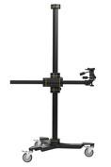

* Height 3.1m
* 高度 2.5 m
* Extension 1.7 m
* 横臂长 1.7m
* Tilt and swivel head with adapters
* 摆动和旋转头,附带连接适配器

# Acceptance

**验收**

* Acceptance test carried out at your site
* 验收测试在客户现场
* Verification of measurement accuracies with dumbbells and flatness normals in accordance with VDI2634 part 3
* 验收测试使用哑铃状球排和平面规等标准计量块,根据 VDI2634 第三部分标准
* Proprietary certificate for each measurement area
* 每套测量范围均校准

Item 2: Photogrammetry

摄影测量系统

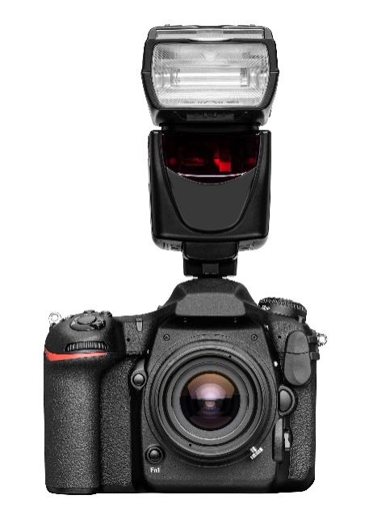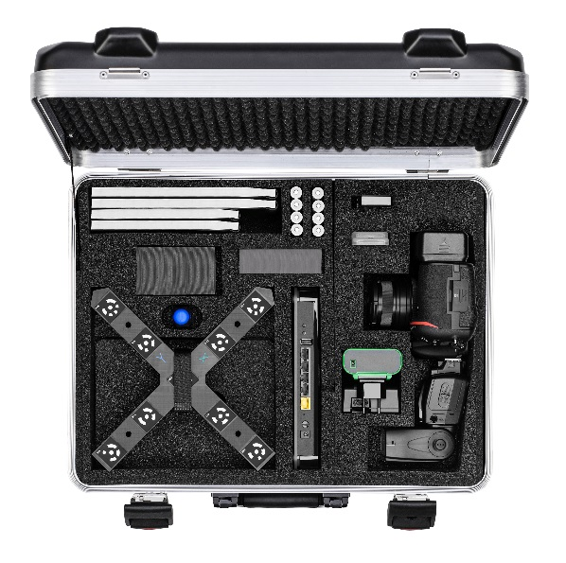

**Digital Measuring Camera With DX-fomat Sensor**

**数码测量相机**

* + Digital reflex camera with color CMOS sensor
  + 彩色单反数码相机
  + Resolution: 21 million effective pixels
  + 分辨率：21 百万像素
  + Sensor size：23.5mm X 15.7mm（DX-format）
  + 相机尺寸：23.5mm X 15.7mm（DX-format）
  + Built-in LCD display
  + LCD 显示屏
  + Certification of the measuring camera
  + 测量相机认证
  + 2 SD memory cards with USB card reader
  + 2张带有USB读卡器的SD存储卡
  + Measuring lens: Titanar 24 mm, f = 2,8
  + 测量镜头：Titanar 24 mm, f = 2,8
  + Lithium-ion battery with charger
  + 可充电的锂电池和充电器
  + Wifi adapter for wireless image transfer
  + 无线适配器
  + Shoe mount flash
  + 闪光灯
  + 2 sets of rechargeable batteries with quick charger
  + 2 组可充电电池和充电器
  + Transport case
  + 运输箱
  + Software support
  + 软件支持
  + Acceptance test
  + 测试报告

# XL-Software for ATOS

**集成在 ATOS 软件内的 Tritop 模块**

* + Base module

基本功能

* + Read in of measuring images via WIFI, memory card or hard disk
  + 通过 WIFI，读卡器或硬盘读取测量照片
  + Processing of flat-white and retro-reflective markers
  + 处理亚光白或荧光反射标记点
  + Error-detecting decoding of markers 0-428
  + 数码点 0-428 号的错误探测
  + Fully automated orientation of images
  + 自动定位照片
  + Simultaneous camera calibration
  + 同步相机标定
  + Navigation via 3D Image Mapping
  + 3D 图片地图向导
  + Automatic computation of 3D coordinates
  + 自动计算 3D 坐标系
  + Export of 3D coordinates in user-defined formats
  + 导出 3D 坐标系
  + Interface for ATOS
  + ATOS 接口
  + User manual
  + 使用手册

# Scale Bars

**比例尺**

|  |  |
| --- | --- |
|  |  |

* + 1 set of CFK scale bars: 2 x 1 m
  + 一组 2x1m 的碳纤维比例尺
  + Transport bag
  + 运输包
  + Calibration certificates
  + 标定认证

# Signaling Material

**编码材料**

* + 2 sets of magnetic, coded white point markers (3, 5mm point diameter)
  + 2 套磁性参考点（点直径 3，5mm）
  + 6 orientation crosses (5 mm point diameter)
  + 6 个 5mm 点直径的数码十字架
  + 4 sets of uncoded white single point markers
  + 4 卷非编码参考点

# Item 3: Measuring area

* Measuring area: 500x 370 mm2
* 单幅测量范围: 500x 370 mm2
* 球形误差（sigma） 0.007mm
* 球间距精度：0.022mm
* Lenses for this measuring area
* 对应测量体积的镜头
* Calibration object for this measuring area with certificate
* 对应测量体积的标定物
* Acceptance test carried out at our site with dumbbells in accordance to VDI2634 part 3
* 根据 VDI2634 第 3 部分的验收证书
* Acceptance certificate with traceability verification
* 可追溯性验证证书

# Item 4: Measuring area

* Measuring area: 1000x750 mm2
* 单幅测量范围: 1000x750 mm2
* 球形误差（sigma） 0.010mm
* 球间距精度：0.038mm
* Lenses for this measuring area
* 对应测量体积的镜头
* Calibration object for this measuring area with certificate
* 对应测量体积的标定物
* Acceptance test carried out at our site with dumbbells in accordance to VDI2634 part 3
* 根据 VDI2634 第 3 部分的验收证书
* Acceptance certificate with traceability verification
* 可追溯性验证证书

# Installation and Training

**安装及培训**

* + 5 days of training in our or in your company
  + 5 天的培训在客户现场

# Support for 12 Months

**12 个月的支持**

* Software updates for bug-fix releases free of charge
* 软件免费升级
* Phone and email hotline
* 电话和邮件支持
* Warranty: 12 months，except human factors and irresistible factors such as flood, fire, earthquake, war...

质保期：12 个月, 人为及不可抗拒因素除外（如水灾、火灾、地震、战争等）